MEDDEV 2.7/1 revision 4
- This document promotes a common approach to clinical evaluation for medical devices regulated by directives 90/385/EEC and 93/42/EEC.
- It does not concern in vitro diagnostic devices.
Scope: This guide is not legally binding; only the text of the Directives is authentic in law.
Due to the participation of interested parties and of experts from national Competent Authorities, it is anticipated that this guide will be followed within the Member States, thereby supporting uniform application of relevant provisions of EU Directives and common practices.
5 Stages of Compiling the Clinical Evaluation

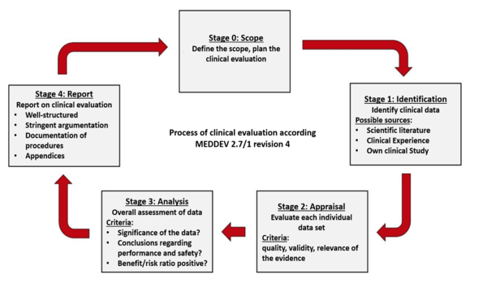

Key changes and clarifications

- Clarification: Frequency of updates to the Clinical Evaluation Report (CER)

Clause 6.2.3 requires the CER to be updated at least annually for high risk or new devices, and every 2 to 5 years for lower risk, well-established devices. A justification for the frequency of updates will be required. For all risk classifications of devices, the CER will need to be updated whenever new information from the Post Market Surveillance (PMS) affects the evaluation or its conclusions.

- New requirement

Qualifications of report authors and evaluators. Clause 6.4 introduces specific requirements for the expertise and experience of CER authors and evaluators, including a relevant higher education degree and five years’ related professional experience, or ten years’ professional experience if a degree is not considered a prerequisite for the task. Deviations from these requirements should be documented and duly justified. All evaluators must now make a declaration of interest.

- Clarification: Specific and measurable objectives for the CER.

Revision 3 of MEDDEV 2.7.1 required the manufacturer to document the objectives and scope of the CER, and to define these in terms of safety, performance and risk endpoints related to the Essential Requirements – but the link between scope and endpoints was perhaps somewhat buried in Appendix F, the Clinical Evaluation Checklist for Notified Bodies. Revision 4 makes the requirement for the objectives of the CER to be linked to specific safety, performance, and risk-benefit endpoints clearer; detailed guidance is provided in Section 7 and Appendix 5.

- Clarification Establishing the state of the art.

Clause 8.2 provides more detail with respect to establishing and documenting the state of the art and available treatment options. This includes establishing the safety and performance of the device, its claimed equivalent(s), and any benchmark or other similar devices, as well as the risks and benefits of other available treatment options.

- Clarification: Scientific validity of data.

The new revision places much greater emphasis on demonstrating the scientific validity of data, including statistical considerations. Section 9.3.1 (“How to evaluate methodological quality and scientific validity”) addresses factors which can affect the scientific validity of different types of datasets. In addition, clarifying and explanatory detail is provided throughout the guidance document for each stage of the clinical evaluation process: factors which could affect the completeness, objectivity or weight of data are described, including literature search and retrieval methods (Section 8 and Appendix 5), data appraisal and weighting (Section 9 and Appendix 6), and the analysis of data and demonstration of conformity (Section 10 and Appendix 7).

- Clarification: Equivalence.

What was just a footnote in Appendix F of Revision 3 of the guidance document has been expanded considerably in Revision 4, and the requirements for demonstration of equivalence are described in detail in Appendix 1. The criteria (clinical, technological, biological) are unchanged, but more information on how this should be documented and factors which could affect the demonstration of equivalence are provided. In particular, Revision 4 requires that design differences and their impacts on clinical safety and performance be described in detail, that comparative drawings and diagrams should be provided, and that each individual device with which equivalence is claimed must meet all three equivalence criteria.

- New requirement: Access to data for equivalent devices.

Revision 4 also requires that the Notified Body challenge the manufacturer’s access to data on the equivalent device(s) (Appendix A12.2.3); this is considered a transition point for the Regulation, which will require a manufacturer to have a contract in place allowing access to data for competitor devices with which equivalence is claimed.

- Clarification: When is a clinical investigation required?

Appendix 2 describes key considerations relating to device risk and how manufacturers should determine if they have sufficient clinical evidence.

- Clarification: Risk-benefit.

Appendix 7 provides detailed guidance on the analysis of data to demonstrate device safety and performance. Appendix 7.2 discusses the risk-benefit profile, including the evaluation and quantification of benefits and risks, and the evaluation of the overall risk-benefit profile. The value of post-market data, and factors which could affect the statistical validity of the evaluation of this data, are addressed in some detail.

- Clarification: Post Market Surveillance (PMS) and Post Market Clinical Follow-up (PMCF).

Throughout Revision 4 of the guidance document, the links between clinical evaluations, PMS and PMCF are reinforced. Appendix 12 highlights the requirement for Notified Bodies to ensure that PMCF is planned and appropriately justified considering the data retrieved and conclusions documented in the CER.

